

**SCHOOL OF COMPUTING**

**SESSION 2024/2025, SEMESTER 2**

**SECV2113 - HUMAN COMPUTER INTERACTION**

**SECTION 01**

**PROJECT PROPOSAL**

**LECTURER NAME:**

ASSOC. PROF. TS. DR. MASITAH GHAZALI

**BY: GROUP 6**

| **NAME** | **MATRICS NO** |
| --- | --- |
| ANATASYA HUMAIRA | A20EC0261 |
| Layth Amjad Hammad | A23CS4024 |
| HARITZ HAYKAL BIN NAZRUL HISHAM | A24CS0250 |
| MUHAMMAD AL-HAKIMI HAIKAL | A24CS0271 |
| AHMAD MUZHAFFAR PRIHANTONY | A23CS4035 |

**TOPIC: GOOD HEALTH AND WELL-BEING**

**Problem**

In this day and age, good health and well-being has become one of the many problems that people struggle with and it is also 1 of 17 Sustainable Development Goals identified by the United Nations. People that struggle with mental health often have problems with accessibility and ease of use, especially people that struggle with anxiety, stress, or emotional fatigue. These users prefer systems that are simple, straightforward and easy to navigate. Currently, most platforms do the opposite of these things and as a result make the users feel even more stressed when attempting to seek help, making the platform less effective for their mental well-being.

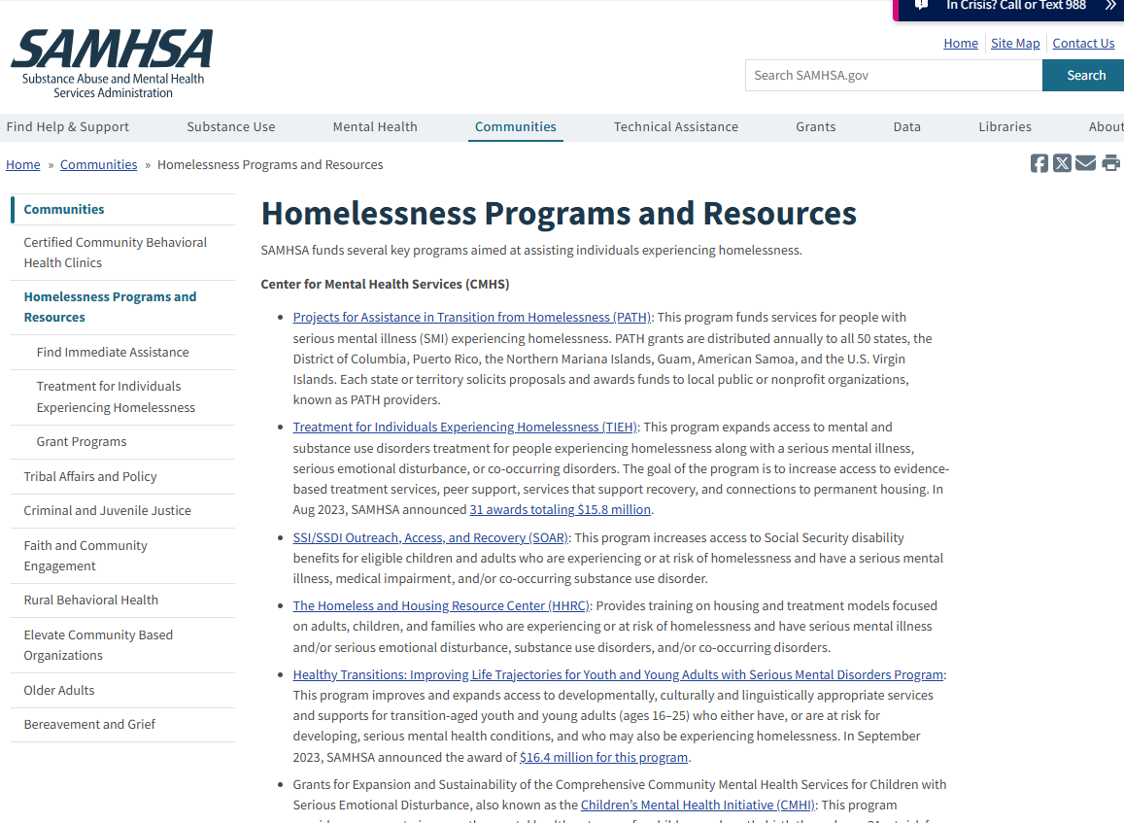

Figure 1: https://www.samhsa.gov/communities/homelessness-programs-resources

Other than claustrophobic mental health websites, there is also poor tracking in Health & Fitness Apps as one of the problems. Health and fitness apps are designed to support users in tracking their physical activities and wellness routines, but many fail due to usability issues. These apps often require manual input which can become very annoying and time-consuming for many users. Additionally, unclear feedback or a lack of progress visualization makes it difficult for users to stay motivated. This makes many users feeling stressed out and will lead to the user giving up on the app which makes it difficult for users to keep up a healthy lifestyle.

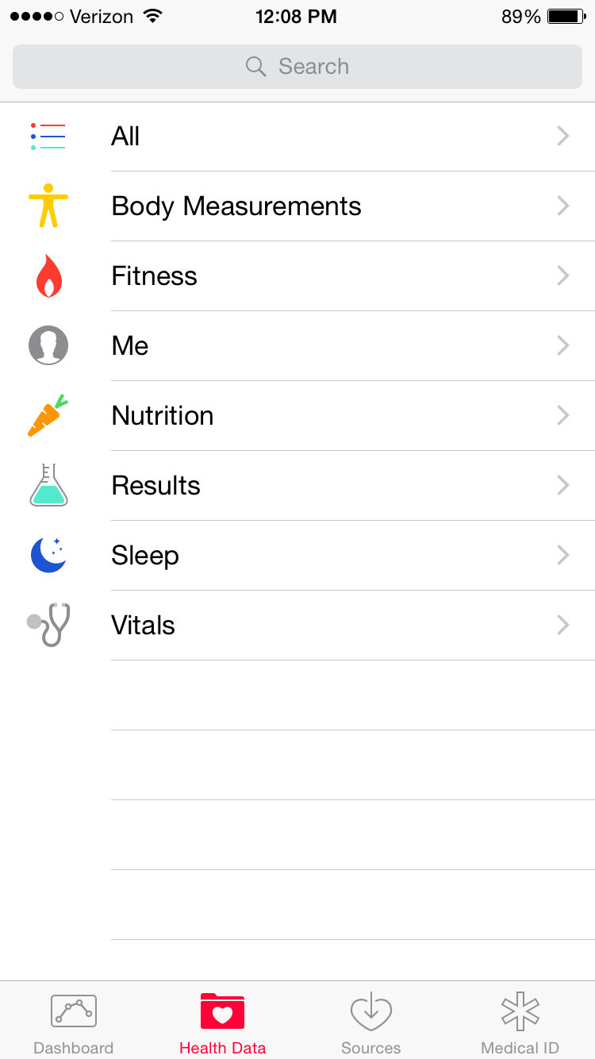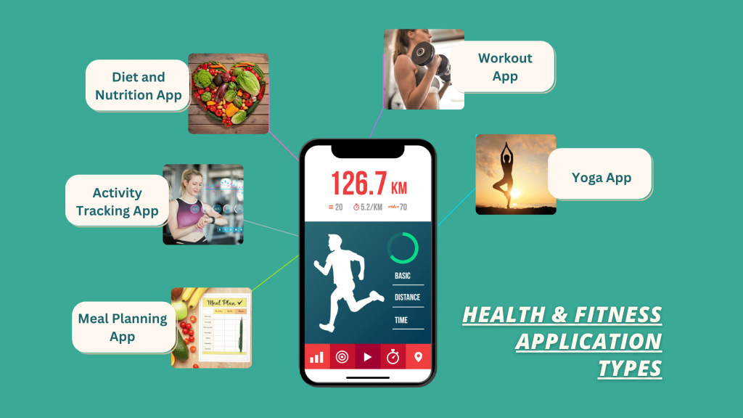

Figure 2.1 & 2.2: UNC Healthy Heels & ValueAppz

Lastly, there is also a lack of health awareness tools for students. Many students struggle to maintain healthy habits during school due to a lack of engaging and accessible health awareness tools. While there is information on the Internet, it is often difficult to find solid and consistent information on certain health topics. This makes the students unsure of which method to apply on improving their health. Current platforms rarely use interactive features that appeal to younger users or support consistent engagement. Therefore, students could be missing out on basic aspects of health such as nutrition, sleep and hydration, all of which can improve their overall physical health and academics.



Figure 3: <https://mcdanielnutrition.com/tips-for-college-students/>

**Solution**

As stated in the problem overview above, the current mental health platforms such as SAMHSA's Homelessness Resources site, are often information-heavy and quite visually overwhelming to some users, especially those struggling with anxiety, stress, or emotional fatigue that would have to encounter difficulty navigating through dense information and complicated UI designs. This contradicts with the good UI/UX practices, where simplicity and clarity are prioritized to reduce cognitive load. In UI/UX standards as well as in accordance with Nielsen's Heuristics, a good system should prioritize user-centered design, making operations intuitive, providing immediate feedback, supporting user control, and minimizing user memory load.

Therefore, in response to the usability and user experience issues, we propose a solution named XXXXX, an intuitive health and wellness application aimed at supporting mental health, physical fitness, and health awareness, particularly among students and young adults.

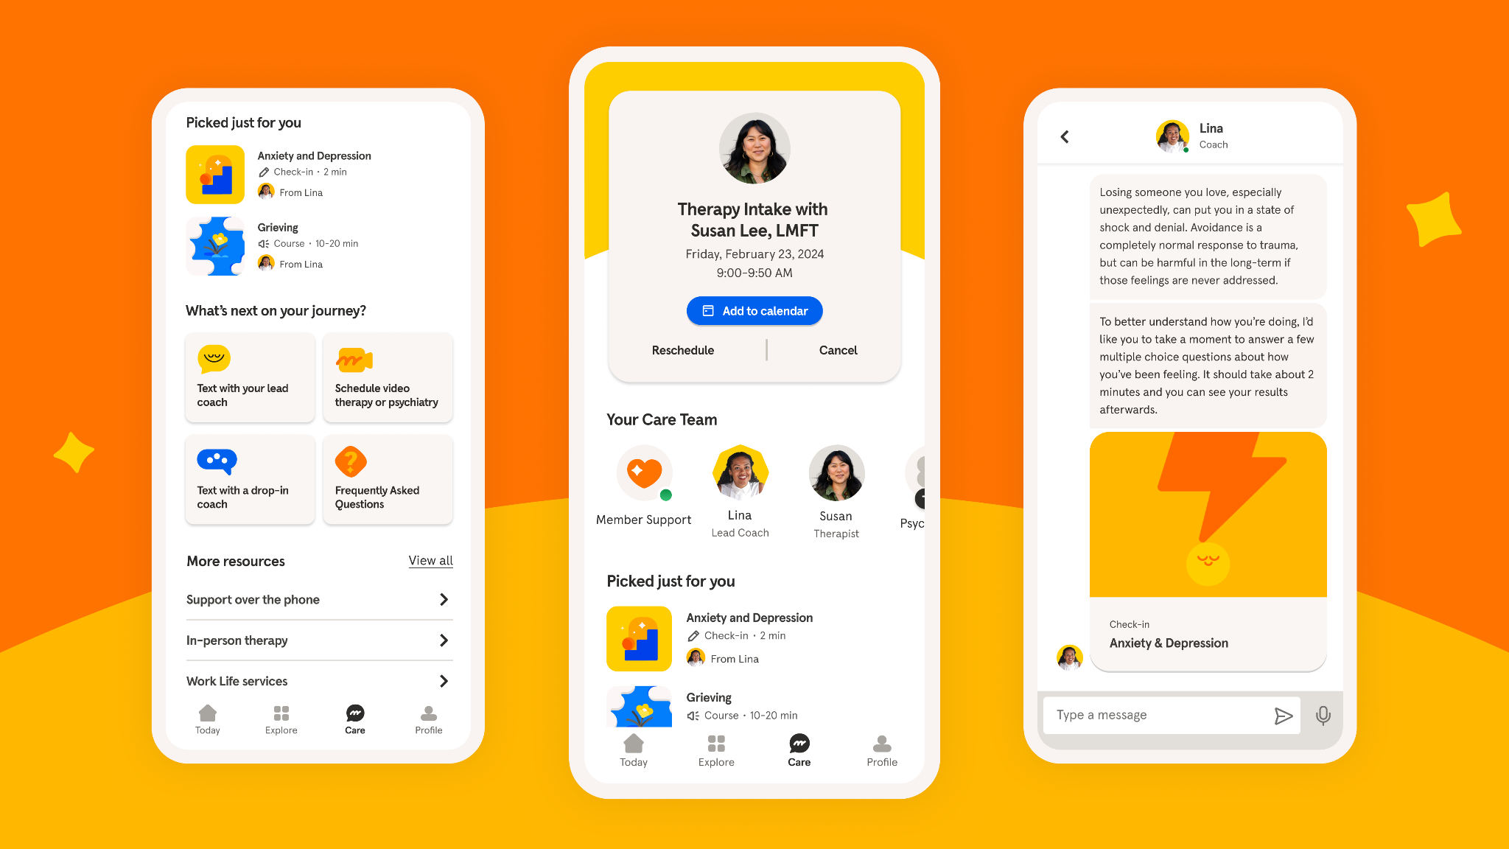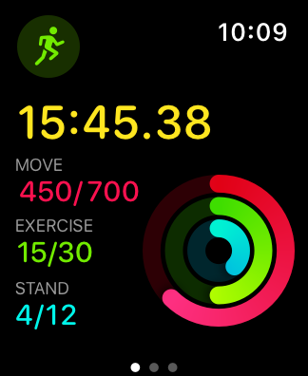

Figure 4.1 & 4.2: Headspace Interface & Apple's Activity Rings

XXXXX is designed as a web-based health and wellness application that delivers a simple, engaging, and supportive environment for users to improve their mental and physical well-being. XXXXX draws inspiration from successful products such as Headspace for meditation simplicity, Apple's Activity Rings for motivational visualization, and Duolingo for engaging, gamified learning. Research from the field of Cognitive Load Theory supports the idea that minimizing the amount of information presented at once reduces user frustration (Sweller, 1998).

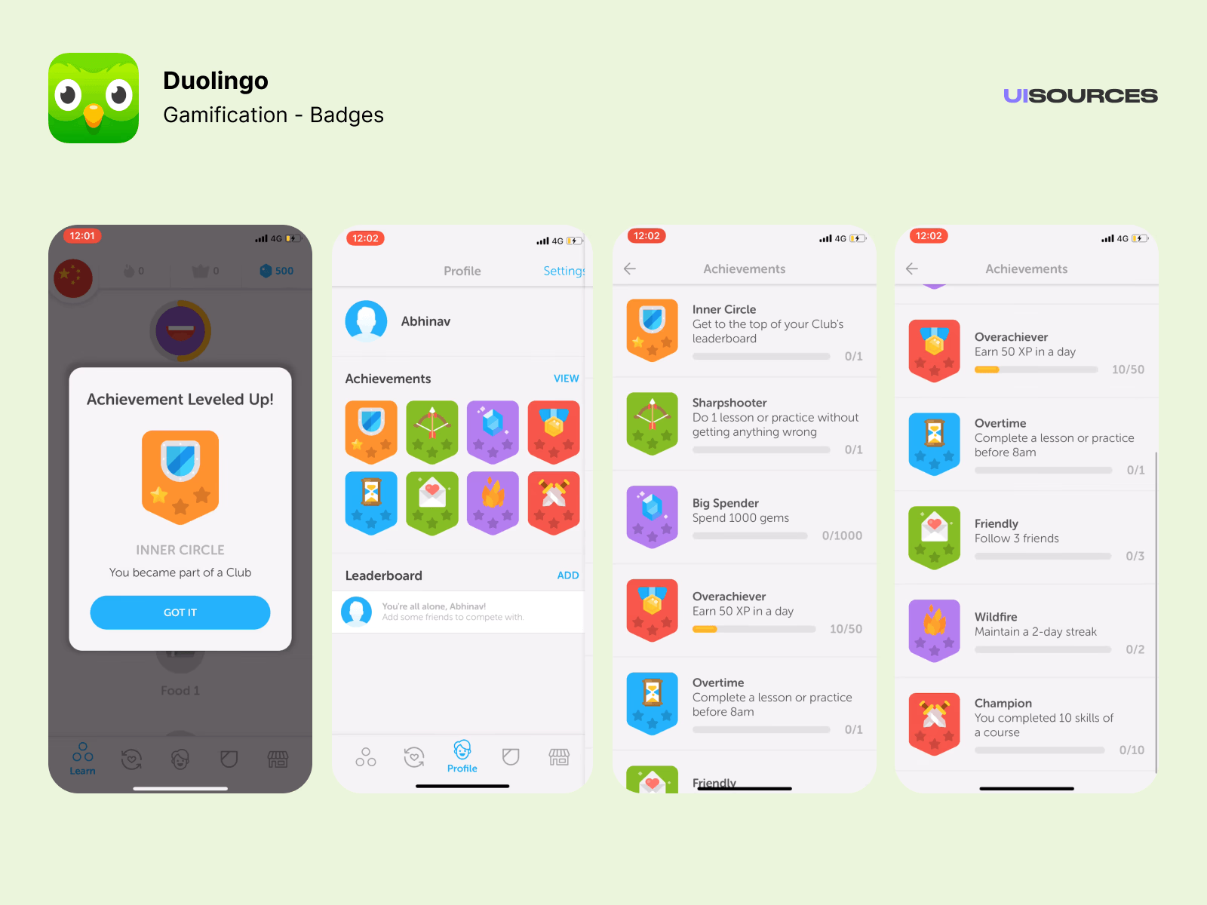

Figure 5: Duolingo Gamification Strategy

The app will feature a calm, minimalistic interface in order to create a soothing user experience. The navigation system will be linear and straightforward, reducing the number of actions required to access key features. To solve the problem of overwhelming platforms, XXXXX will use progressive disclosure, displaying only essential options first and allowing users to dive deeper if they wish, preventing information overload.

As for the fitness tracking, XXXXX will minimize manual inputs by integrating wearable device support. For instance, Apple HealthKit, Google Fit and automatic activity detection to capture steps, exercise routines, sleep patterns, and hydration levels. By integrating these APIs, XXXXX can automatically gather real-time health metrics without requiring users to log their activities manually, significantly reducing user effort and friction. Additionally, visual feedback will be provided as well through simple, colorful progress rings and achievement badges, using clear, celebratory feedback to maintain user motivation without overwhelming them with data.

XXXXX will also introduce an interactive learning hub featuring short animated videos, quick quizzes, and gamified challenges just like the ones we could find in shopping platforms such as Shopee. Learning about subjects like diet, mental toughness, and sleep hygiene will be made simpler and more enjoyable for the student users by providing them with responsive, visually appealing, and lifestyle-relevant information.  
  
  
  
  
  
  
.Soothing Visual Design

1-A relaxing and minimalist design in soft pastel tones i.e. light blues and greens that are known to create calm and lower stress.

2-High color-contrast between text and background text-background color-concentration high (e.g., dark on light), to increase legibility for users suffering from vision fatigue or vision abnormalities.

3-Dark mode to empower users to control their visual environment and minimize eye strain, particularly in low-light conditions.

.Font & Typography Choices

1-One carry-over I do understand is the use of rounded, clean looking sans-serif type (like Poppins, Roboto, or Lato), which reads well and has a friendly feel to it.

2-Dynamic fonts allow text to scale with accessibility sizes, so users can adjust it to their comfort.

3-Large legible section headings and enough contrast / whitespace to avoid users being overwhelmed.

**Targeted Users**

Our proposed application, XXXXX, is designed for the following target user groups, but not limited to:

1. University Students

Students today often experience high levels of stress due to academic pressures, social challenges, and time management difficulties. This demanding and high-pressure environment can have negative impacts on both their physical or mental wellness.

XXXXX provides a comprehensive platform that includes features like mental health support, fitness tracking, and health education—with a simple and minimalist interface display, to cope with the packed schedules and hectic and dynamic lifestyles of students, aiding them to maintain their health while also improving their academic performance.

1. Young Working Professionals

Young adults entering the workforce often deal with new mental and physical health challenges, such as long sedentary hours, work-related stress, and struggle in maintaining a balanced lifestyle.

With tight schedules and pressures causing many to put aside their own health, XXXXX app offers accessible, quick exercises, automatic fitness tracking, and stress management resources, all seamlessly integrated into daily routines to support young professionals maintain a healthy and balanced lifestyle.

1. Individuals with Anxiety or Stress Disorders

Conventional mental health platforms can sometimes be too complicated, difficult, or even triggering for people with anxiety, mental fatigue, or stress disorders. By delivering a simple and relaxing interface, hopefully, our app addresses these needs and reduces emotional exhaustion.

Progressive disclosure—presenting information gradually—is used to ensure users are not overwhelmed. The aim is to treat health management as a journey, rather than a list of tasks to be done, using friendly prompts, soothing visuals, and optional activities instead of mandatory steps.

**References:**

1. Sweller, J. (1988). Cognitive Load During Problem Solving: Effects on Learning. Cognitive Science, 12(2), 257–285. <https://doi.org/10.1207/s15516709cog1202_4>
2. Norman, D. A. (2013). The Design of Everyday Things. (Revised and Expanded Edition). MIT Press.
3. Nielsen, J. (1994). 10 Usability Heuristics for User Interface Design. Nielsen Norman Group. Retrieved from <https://www.nngroup.com/articles/ten-usability-heuristics/>